Feedback on Figures:

Figure 1: I wonder if it is too ambitious to have a combined figure of the life cycle model and the map, as you currently have for figure 1. I’ve seen multiple versions of this and each time I’ve gotten a bit caught up trying to map equations and stages to locations. I think I would rather see separate figures showing 1) the life cycle model and 2) a map of the study region with data locations shown. This would also allow you to put more detail on the map.

Life cycle model figure: If on its own, this could include some more detail. My idea would be to do something like this from Ohlberger et al. 2014, except that you could also include the equations and variable names, and indicate which is included in the model likelihood (as you do now in Fig 1).

One question I have is how you want to show harvest and spawning abundance. I would not show these as connected arrows as you have them now, but rather with Returns getting split into harvest and spawners, with spawners then looping around to eggs.

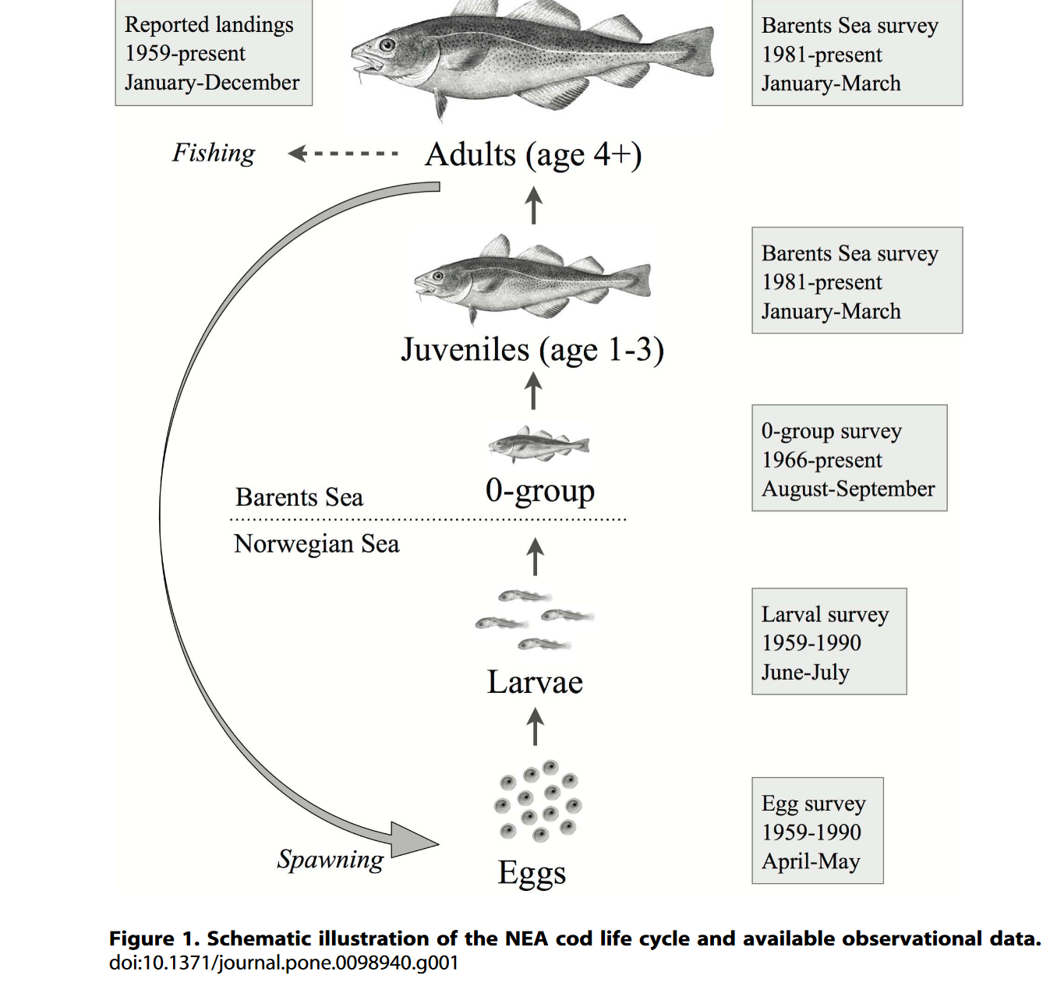

For a second map figure, you could show the watershed, and possibly even add on layers to show where some of the data come from. For instance, an outline of the NBS area where the juvenile survey data come from would be helpful. You could also then outline roughly the migration route and overwintering areas.

Figure 2: I find the “freshwater” label confusing, as two of the juvenile survival covariates are marine. I’d also suggest to reorder the covariates to be in chronological order (moving “Mean Spawner Size” and “Juvenile Fullness Index to each be first in their respective stages). I’m not sure this figure is needed though, especially if you have a table describing the covariates, stages, mechanisms, and lags.

Figure 3: I suggest to line up your X axes between the top and bottom. In the legend you explain the lack of a 2020 datapoint, but what about 2012?

Supplementary figures: I think you’ll want to show the covariate time-series that you use in the model. For instance, I find myself wondering what the spawner size trend looks like. A supplementary figure with a panel for each covariate would be good.